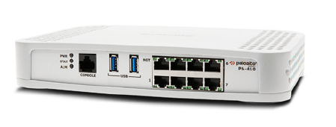

Palo Alto Remote Access VPNs using SSL Configurations

Sophia Zhang | Period 5 Cybersecurity | 2022-2023



**Purpose**

The purpose of this lab was to configure remote access VPNs using SSL configurations on a Palo Alto firewall.

**Background**

Remote Access VPNs give remote users around the world secure connections to the network. An SSL VPN is a type of VPN that uses the SSL protocol. SSL stands for Secure Sockets Layer protocol, which helps provide standard web browsers with secure remote access VPN abilities. SSL VPNs give devices the ability to access the internet with a secure remote access VPN connection with a web browser. SSL VPNs use end-to-end encryption to ensure the safety of the data being transmitted between the endpoint device and the SSL VPN server through which the client connects securely to the internet.

Many organizations use SSL VPNs to securely access resources, and to secure internet access sessions. It supports a variety of operating systems, such as Windows, macOS, iOS, and Android, making it very popular, accessible, and suitable for all remote users.

SSL VPNs are also popular among administrators. Firstly, they can define access control policies, and control which resources users can use. It lets them have a more secure network to prevent security breaches by limiting access based on certain rules. These rules include user identity, location of the device, and type of device. Also, Palo Altos provide a lot of information to administrators, including host information profiles, which allows them to enforce endpoint security checks before giving remote users access by checking if they meet the security requirements.

Because of all of these positive features of SSL VPNs, it is a popular and excellent solutions for organizations who are looking for a way to secure remote access to their networks. There are effective security measures, helping organizations ensure that their networks are safe.

**Lab Procedure**

1. Follow the configuration guide for global protect, these configs are additional configurations to do on top of that
2. Install the GlobalProtect Clientless VPN

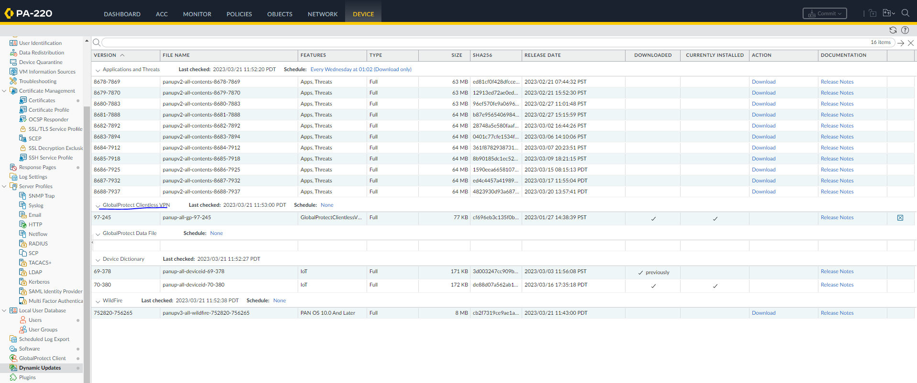

1. Go to portals and configure the following

1. go to Clientless VPN and configure the following

1. go to Crypto Settings and configure the following

1. create a clientless application

1. Set up a DNS Proxy

1. Configure User Mapping

Set up user mapping

1. If you haven’t already, to do this you need to set up a local webserver using Apache or some other application.

**Problems**

Initially we didn’t know we needed a local webserver for the lab. We had to learn a little bit of HTML and download Apache. Majority of the configs went really smooth though we did forget a few of the commands. The loading was kind of slow, so we looked for problems that didn’t exist when our user and password weren’t giving us access to the Palo Alto page, but it was just that it took a few minutes for changes to process over the web. We also forgot to connect to the right ports at times which was a layer 1 issue but an issue, nonetheless. Overall, this lab only took 2 days to finish, so it was relatively fast.

**Summary**

In this lab, we configured remote access with clientless SSL VPNs on a Palo Alto Firewall.